Specification-Based Testing

What is Specification-Based Testing
# Source: AI Source: Provided by: [Data Path: Persons Table -> ID Column: 1, Name_En Column: Motasem Essam] -> From: [Chatgpt (GPT‑5 Mini)] on [8/24/2025]
Specification-based testing is a category of black-box testing techniques where test cases are designed based on the specifications (requirements, use cases, functional descriptions) of the system — not on the code or internal structure.
👉 In other words:
- You test what the system should do (according to requirements),
- Without knowing how it is implemented.

🔑 Key Characteristics
# Source: AI Source: Provided by: [Data Path: Persons Table -> ID Column: 1, Name_En Column: Motasem Essam] -> From: [Chatgpt (GPT‑5 Mini)] on [8/24/2025]
- Based on external specifications (functional requirements, user stories, business rules, etc.).
- Focuses on input/output behavior.
- Independent of code structure.
- Often used at all test levels (unit, integration, system, acceptance).

🛠️ Common Specification-Based Techniques
# Source: AI Source: Provided by: [Data Path: Persons Table -> ID Column: 1, Name_En Column: Motasem Essam] -> From: [Chatgpt (GPT‑5 Mini)] on [8/24/2025]
- Equivalence Partitioning (EP)
  - Divide input data into groups (“partitions”) where system behavior should be the same.
  - Example: Age field (valid = 18–60, invalid = <18, >60).
- Boundary Value Analysis (BVA)
  - Focus on values at the edges of input ranges.
  - Example: Test ages 17, 18, 60, 61.
- Decision Table Testing
  - Use a table to capture different input combinations and expected outcomes.
  - Example: Loan approval rules (income level + credit score).
- State Transition Testing
  - Model system states and transitions between them.
  - Example: ATM (Idle → Card Inserted → PIN Entered → Transaction).
- Use Case Testing
  - Based on user interactions and workflows.
  - Example: Testing the checkout process in an e-commerce site.

✅ Benefits
# Source: AI Source: Provided by: [Data Path: Persons Table -> ID Column: 1, Name_En Column: Motasem Essam] -> From: [Chatgpt (GPT‑5 Mini)] on [8/24/2025]
- Tests are derived directly from requirements → good alignment with customer expectations.
- Easy to explain to business stakeholders.
- Helps uncover missing or ambiguous requirements.

⚠️ Limitations
# Source: AI Source: Provided by: [Data Path: Persons Table -> ID Column: 1, Name_En Column: Motasem Essam] -> From: [Chatgpt (GPT‑5 Mini)] on [8/24/2025]
- If the specification is incomplete or wrong, tests will also be incomplete/wrong.
- Doesn’t guarantee coverage of internal code paths (unlike white-box testing).

📖 Example
# Source: AI Source: Provided by: [Data Path: Persons Table -> ID Column: 1, Name_En Column: Motasem Essam] -> From: [Chatgpt (GPT‑5 Mini)] on [8/24/2025]
Requirement (specification):
Password must be between 8–12 characters, contain at least one number.
Specification-based test cases:
- Input: "abc123" → Fail (too short).
- Input: "abcdefgh" → Fail (no number).
- Input: "abcd1234" → Pass.
- Input: "abcdefghijkl123" → Fail (too long).

IS Black-Box Techniques IS SAME Specification-Based Techniques

1. Black-Box Techniques
# Source: AI Source: Provided by: [Data Path: Persons Table -> ID Column: 1, Name_En Column: Motasem Essam] -> From: [Chatgpt (GPT‑5 Mini)] on [8/24/2025]
- Big umbrella term.
- Means testing without looking at internal code structure.
- Focus is only on inputs and expected outputs.
- Includes different sub-categories of techniques.

2. Specification-Based Techniques
# Source: AI Source: Provided by: [Data Path: Persons Table -> ID Column: 1, Name_En Column: Motasem Essam] -> From: [Chatgpt (GPT‑5 Mini)] on [8/24/2025]
- A subset of Black-Box Techniques.
- Specifically, test design is based on the system’s specification (requirements, functional design, use cases, business rules, etc.).
- Examples:
  - Equivalence Partitioning (EP)
  - Boundary Value Analysis (BVA)
  - Decision Table Testing
  - State Transition Testing
  - Use Case Testing

🔄 Relationship
# Source: AI Source: Provided by: [Data Path: Persons Table -> ID Column: 1, Name_En Column: Motasem Essam] -> From: [Chatgpt (GPT‑5 Mini)] on [8/24/2025]
✅ All Specification-Based Techniques are Black-Box Techniques.
❌ But not all Black-Box Techniques are Specification-Based.
Because in Black-Box we also have:
- Experience-Based Techniques (Error Guessing, Exploratory Testing, Checklist-Based, Attack-Based).
- Collaboration-Based Approaches (BDD, ATDD, SbE, Exploratory Workshops).

📊 Comparison Table
# Source: AI Source: Provided by: [Data Path: Persons Table -> ID Column: 1, Name_En Column: Motasem Essam] -> From: [Chatgpt (GPT‑5 Mini)] on [8/24/2025]
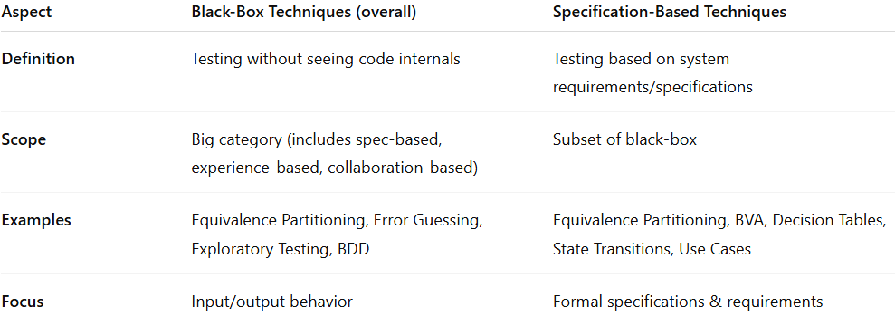
Aspect | Black-Box Techniques (overall) | Specification-Based Techniques
Definition | Testing without seeing code internals | Testing based on system requirements/specifications
Scope | Big category (includes spec-based, experience-based, collaboration-based) | Subset of black-box
Examples | Equivalence Partitioning, Error Guessing, Exploratory Testing, BDD | Equivalence Partitioning, BVA, Decision Tables, State Transitions, Use Cases
Focus | Input/output behavior | Formal specifications & requirements

⚖️ Final Answer
# Source: AI Source: Provided by: [Data Path: Persons Table -> ID Column: 1, Name_En Column: Motasem Essam] -> From: [Chatgpt (GPT‑5 Mini)] on [8/24/2025]
👉 Specification-Based Testing = One category inside Black-Box Testing.
So they are not the same, but specification-based belongs under black-box.

⚖️ Summary
# Source: AI Source: Provided by: [Data Path: Persons Table -> ID Column: 1, Name_En Column: Motasem Essam] -> From: [Chatgpt (GPT‑5 Mini)] on [8/24/2025]
Specification-based testing = designing tests from requirements/specifications, focusing on system behavior rather than code.
Techniques include Equivalence Partitioning, Boundary Value Analysis, Decision Tables, State Transition, and Use Cases.

